Identification of Objects Using the Color Histogram

C. Emiliano Solórzano Espíndola,[*carlosemiliano04@gmail.com*](mailto:carlosemiliano04@gmail.com)

*ETSEIB-* *Universitat Politècnica de Catalunya*

***Abstract*— The present works was developed in order to identify an object different from the original background image, previously showed to the computer. After that, using the ROI’s RGB histogram, a feature vector is created capable of differentiate among some objects using for classification.**

Algorithm description

In the first step the background image is obtained in order to distinguish the initial values of the scene that is presented to the computer, for this the camera must stay in the same spot during all the processing. We can call this image $I_{0}$ and is represented by an *n*m*3* matrix where *n* and *m* are the size of the image, and 3 is the number of channels we are using to represent it, in this specific case the RGB space.

Once the computer has processed the background image, a new cycle of video input enter to the algorithm where each frame $I_{n}$ is compared to the original background image. From this the ROI is obtained using the following steps:

* Subtract the original background image to the new frame.

$$I_{n}-I_{0}$$

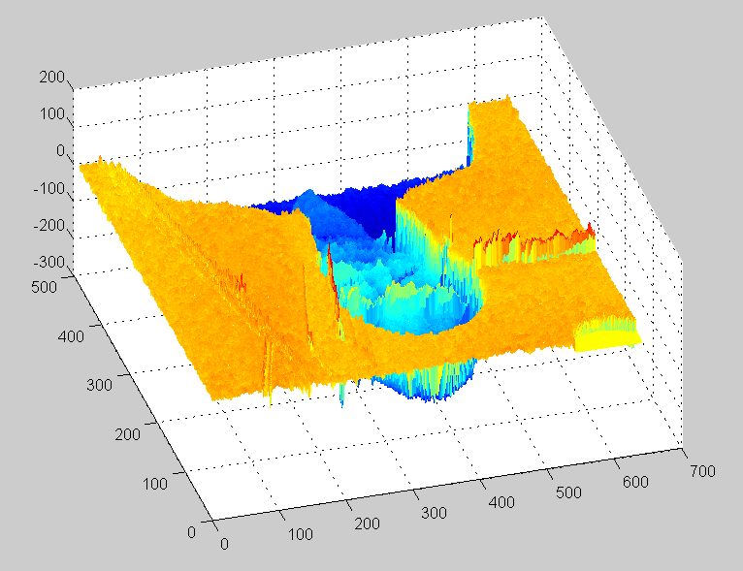

Figure 1. Mesh of the new subtracted image, it can be seen that there are positive and negative values

* The new image will have the positives and negative differences from the images, so we square the whole matrix. This also helps to make the difference from the original even bigger.
$${I_{r}= (I}_{n}-I_{0})^{2}$$

* Create a mask using a user defined threshold for the minimum difference admitted. This mask is used for creating the new image with the isolated ROI.
$$I_{w}=I_{r}>threshold$$

* We create a vector finding the pixels that define the new ROI and after that the RGB histogram is obtained. This histogram uses 5 batches, so we obtain a *5*5*5* matrix with the values that represents the vector’s color. Since the ROI pixels, and not the reconstructed image pixels, are used we can even track black objects.

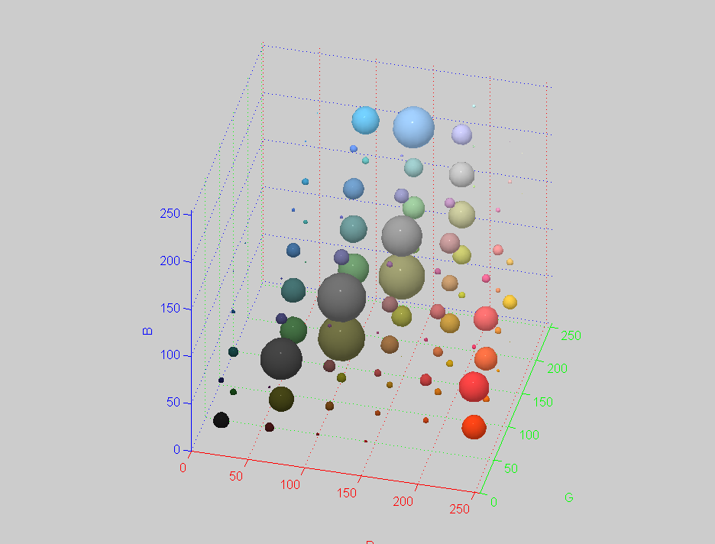

Figure 2. Example of an RGB histogram of an image.

* Convert the new histogram to a 1*125 feature vector, this will define the new object and from this we can either train a new classifier or identify the corresponding class using a previously trained classifier. The output of the classifier is a simple text with the corresponding class.

For the training four objects were used, those were the following ones:

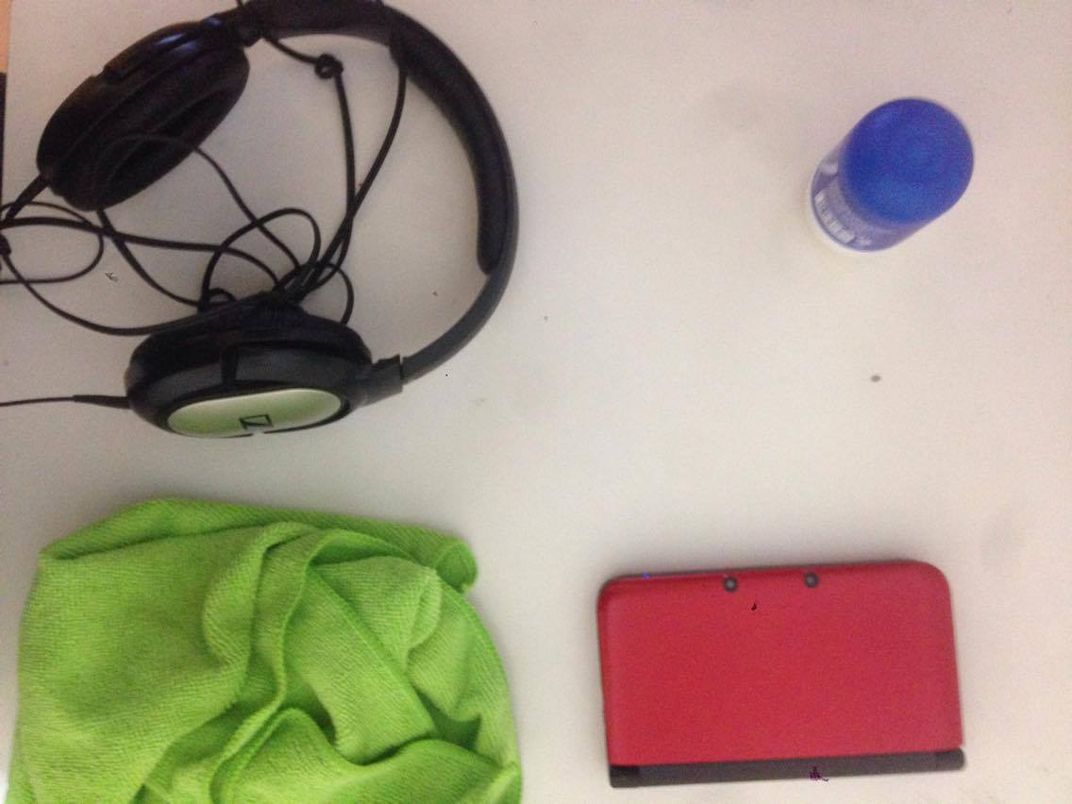

Figure 3. Objects used for the classifier: object 1: upper left, object 2: upper right, object 3: bottom left, object 4: botton right

Using the present algorithm six observations of each object were used as examples for the classifier. To make a comparison of each object’s class and verify if the classifier could differentiate correctly among the classes, the *Mahalanobis distance* was computed. The distance to non-same class was big enough compared same class observations, this is important in order to make an adequate classification, so it was decided that the classifier was correctly trained.

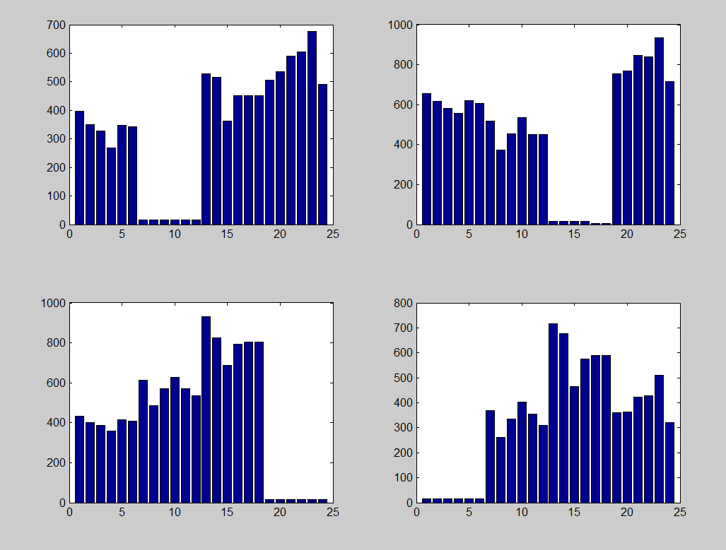

Figure 4. Mahalanobis distance among classes

Results

After the classifier was trained and evaluated, the algorithm handed a live video input were at each frame a ROI was extracted and classified using its histogram, the speed of the algorithm allowed to make a reconstruction of the image in order to monitor if the object was correctly placed in front of the camera. One of the important features of the algorithm is that it was able to detect a black object (object 3).

For the results first the reconstructed image is shown, then its histogram and finally the MATLAB output. They are displayed in the following table:

|  |  |  |  |
| --- | --- | --- | --- |
| **Object 1** | **Object 2** | **Object 3** | **Object 4** |
|  |  |  |  |
|  |  |  |  |
|  |  |  |  |